

MSD SOP for Azure Site Recovery (Modernized) for On Premises VMware Redhat Linux Server

Overview & Goals.

The “Purpose” of a SOP is to provide detailed instructions on how to setup Azure Site Recovery replication appliance – Modernized for ON premises (VMware) machines
Prerequisite for Appliance Server
- Window Server 2019.
- Data disk with 600GB free disk.
- Antivirus should be uninstalled before proceeding.

Go to Recovery Services Vault > Getting Started. In VMware machines to Azure, select Prepare Infrastructure and proceed with the sections detailed below:

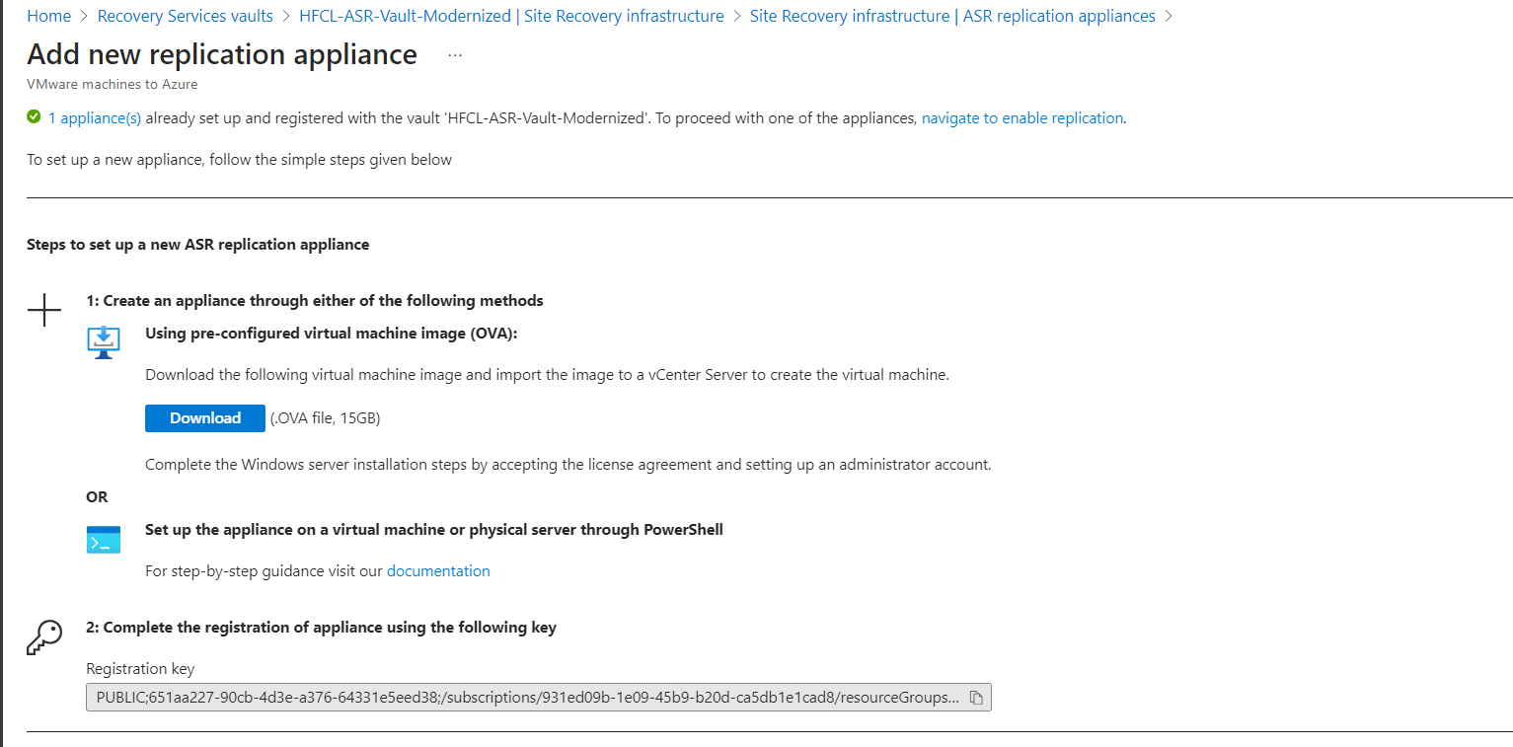

Download the step up from below link-
1,https://aka.ms/V2ARcmApplianceCreationPowershellZip
2.After successfully copying the zip folder, unzip and extract the components of the folder.
3.Go to the path in which the folder is extracted to and execute the following PowerShell script as an administrator:
DRInstaller.ps1

After installation, below url will open, fill up the requirement.
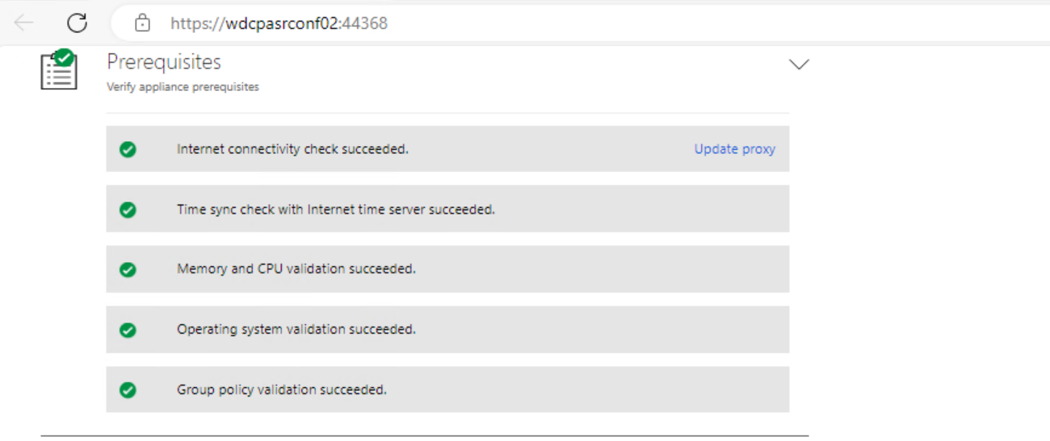

Add vCenter details and credential
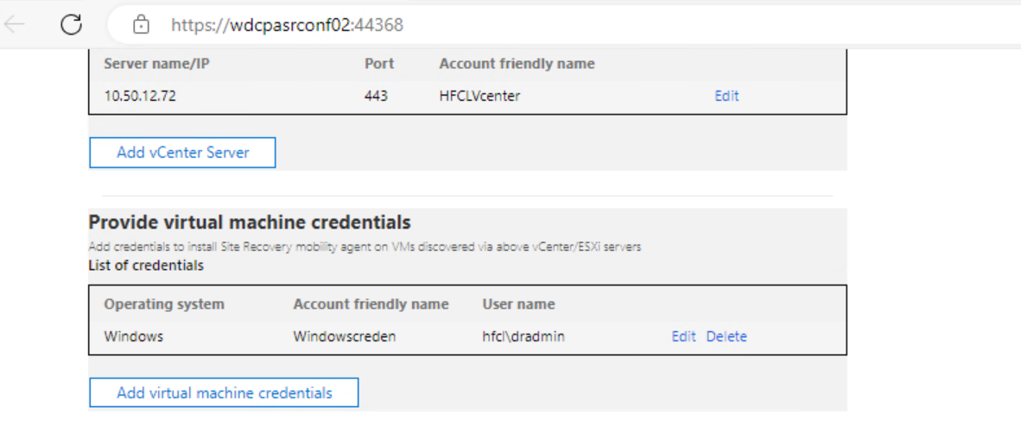

After installation the appliance server will be visible in Azur portal.
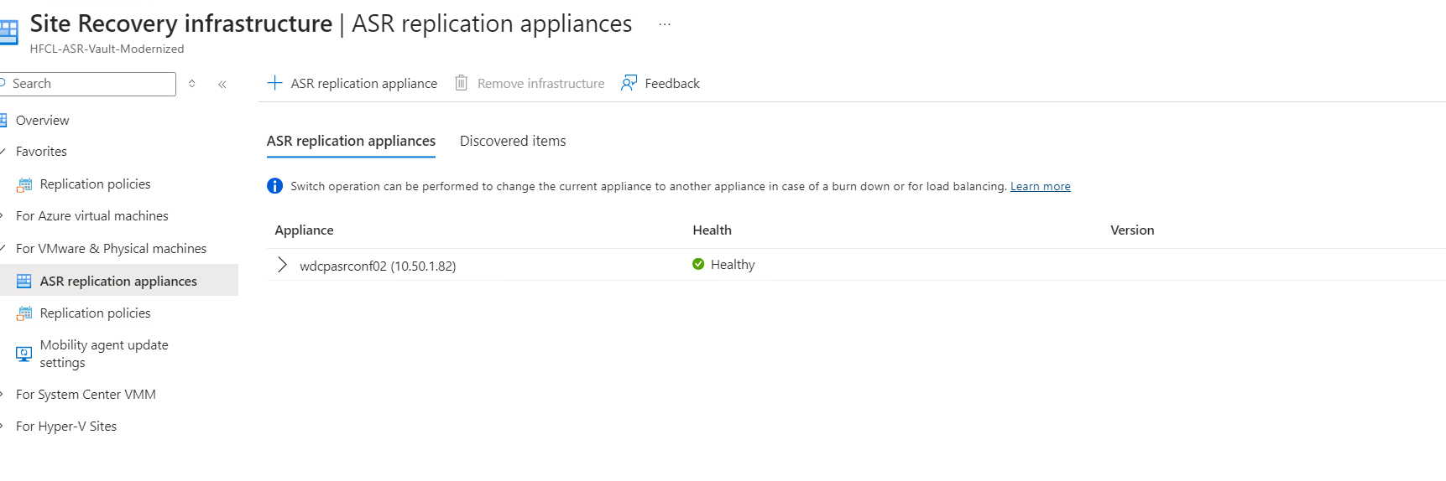

Once the appliance server is ready, disable the replication from OLD ASR
For LINUX Server:

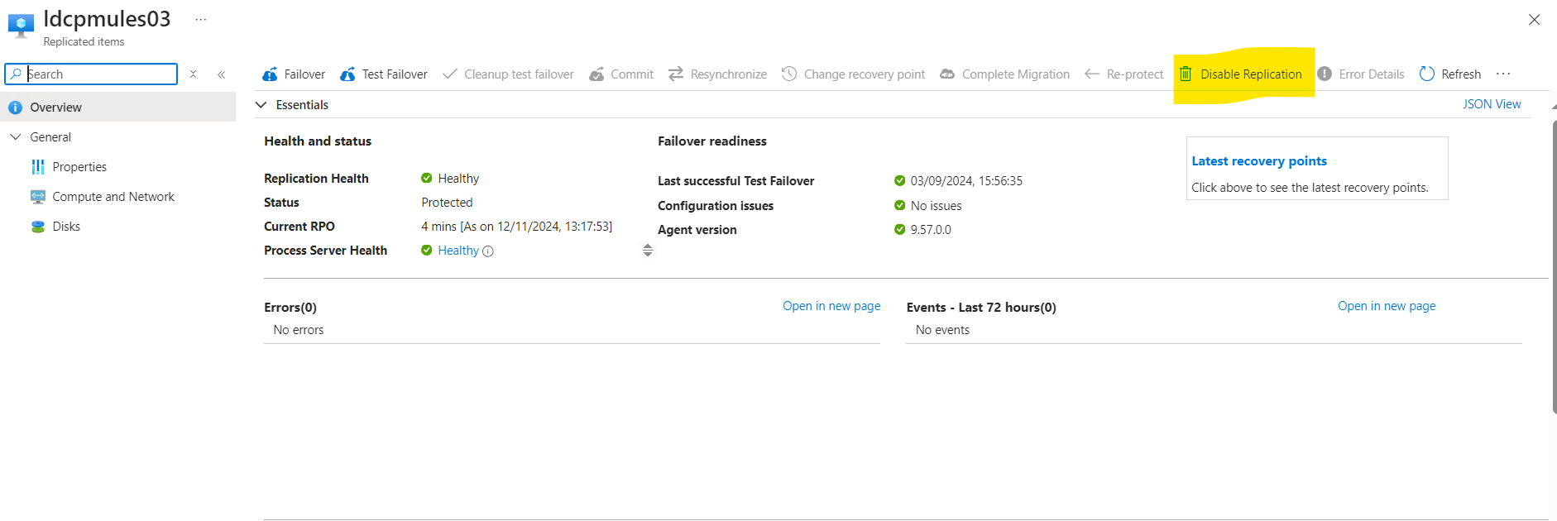
Remove the agent from Source Server and reboot it.
After rebooting install the agent, Location mentioned in below snapshot (10.50.1.82).
About the Mobility service for disaster recovery of VMware VMs and physical servers with Azure Site Recovery - Azure Site Recovery | Microsoft Learn

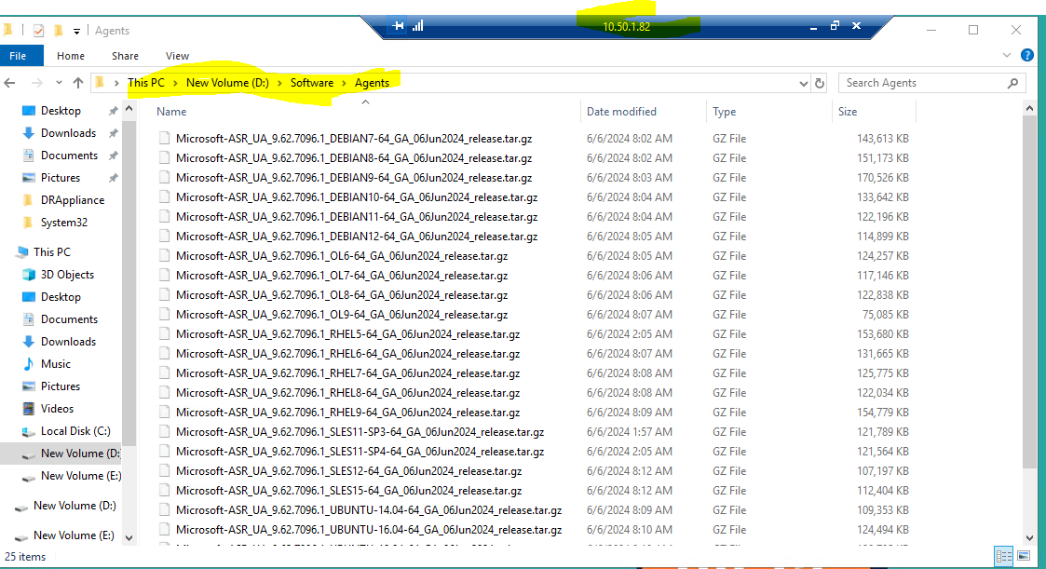

INTALLATION PROCESS:
[root@ldcpmules03 bin]# cd /tmp/
[root@ldcpmules03 tmp]# mkdir Microsoft-ASR_UA_9.57
[root@ldcpmules03 tmp]# cd Microsoft-ASR_UA_9.57/
[root@ldcpmules03 Microsoft-ASR_UA_9.57]# cp /home/dradmin@HEROFINCORP.COM/Microsoft-ASR_UA_9.50.0.0_RHEL8-64_GA_30Jul2022_Release.tar.gz /tmp/
cp: cannot stat ‘/home/dradmin@HEROFINCORP.COM/Microsoft-ASR_UA_9.50.0.0_RHEL8-64_GA_30Jul2022_Release.tar.gz’: No such file or directory
[root@ldcpmules03 Microsoft-ASR_UA_9.57]# cp /home/dradmin@HEROFINCORP.COM/Microsoft-ASR_UA_9.57.0.0_RHEL7-64_GA_13Dec2023_Release.tar.gz /tmp/
[root@ldcpmules03 Microsoft-ASR_UA_9.57]# mount -o remount,exec /tmp
[root@ldcpmules03 Microsoft-ASR_UA_9.57]# tar -xzvf /tmp/Microsoft-ASR_UA_9.57
Microsoft-ASR_UA_9.57/
Microsoft-ASR_UA_9.57.0.0_RHEL7-64_GA_13Dec2023_Release.tar.gz
[root@ldcpmules03 Microsoft-ASR_UA_9.57]# tar -xzvf /tmp/Microsoft-ASR_UA_9.57
Microsoft-ASR_UA_9.57/
Microsoft-ASR_UA_9.57.0.0_RHEL7-64_GA_13Dec2023_Release.tar.gz
[root@ldcpmules03 Microsoft-ASR_UA_9.57]# tar -xzvf /tmp/Microsoft-ASR_UA_9.57.0.0_RHEL7-64_GA_13Dec2023_Release.tar.gz

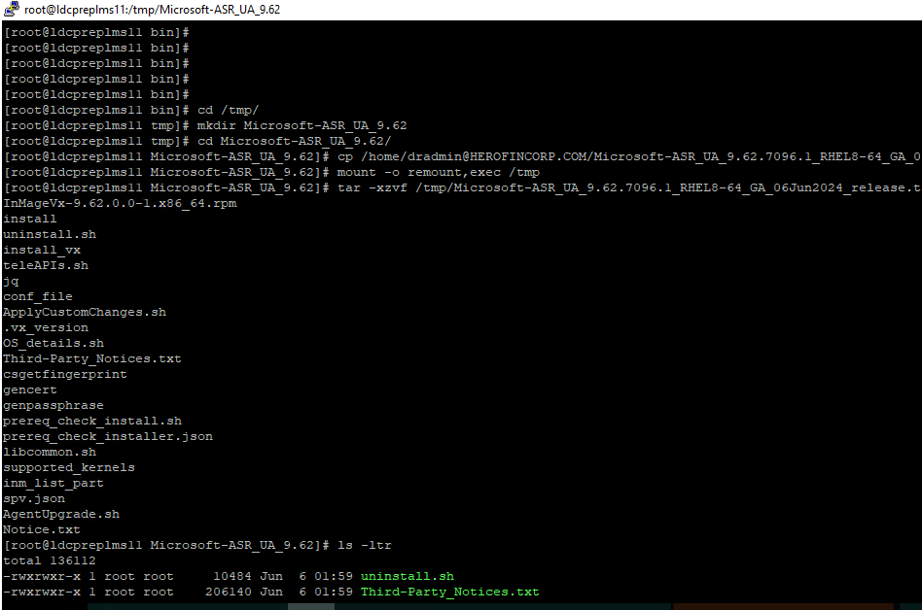

[root@ldcpmules03 Microsoft-ASR_UA_9.62]# sudo ./install -q -r MS -v VmWare -c CSPrim

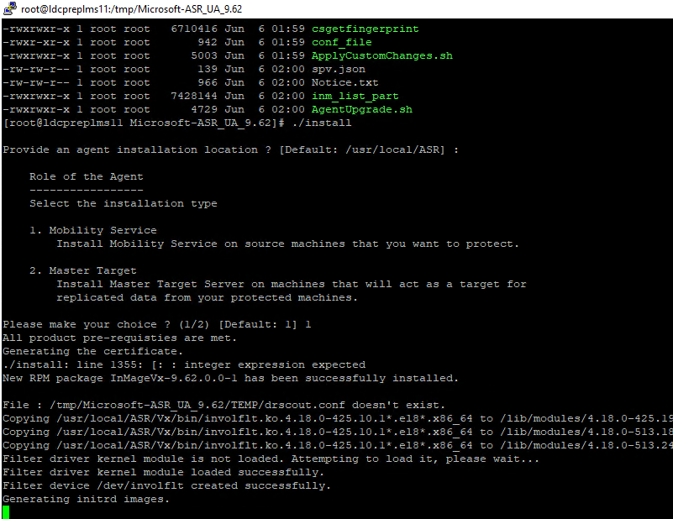
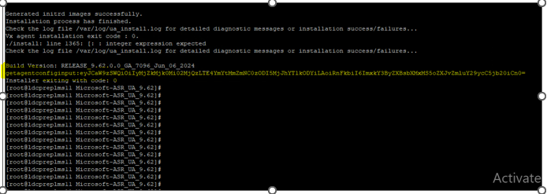
Once the installation is done, you will need to register the source machine with the appliance of your choice. To do so, copy the string present in the field Machine Detail ‘’e.g’eyJCaW9zSWQiOiIzNDBjMjk0Mi00Y2Q4LWE4YTQtM2JkMC1iZTg2ZDUxN2MwN2YiLAoiRnFkbiI6IndkY3BmdG5hcHAwMy5IRVJPRklOQ09SUC5DT00iCn0=’

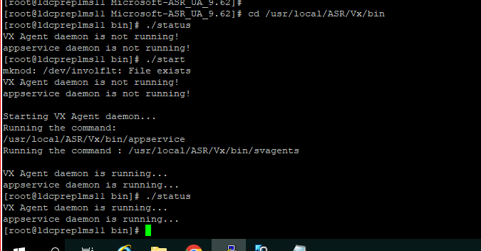

Paste the same in Source Input.
Go to the Mobility service configuration details option then put Getagentconfiginput KEY and download the .json file rename it config.json
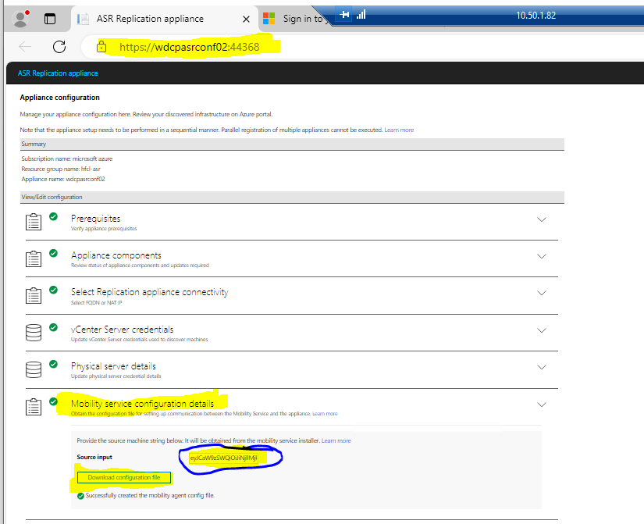
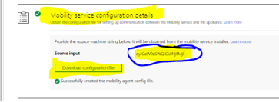

Keep this config.json into VM this location
[root@ldcpnfssrv03 bin]# pwd
/usr/local/ASR/Vx/bin
[root@ldcpnfssrv03 bin]#
-rwxrwx--- 1 root root 7114 Sep 20 11:25 vxagent
-rwxrwx--- 1 root root 33010 Sep 20 11:25 uninstall
-rwxrwx--- 1 root root 29137 Sep 20 11:25 check_drivers.sh
-rwxrwx--- 1 root root 6757 Sep 20 15:01 config.json
-rwxrwx--- 1 root root 0 Sep 20 15:04 config.json.lck
lrwxrwxrwx 1 root root 27 Sep 20 15:04 s2 -> /usr/local/ASR/Vx/bin/s2A2A
lrwxrwxrwx 1 root root 33 Sep 20 15:04 svagents -> /usr/local/ASR/Vx/bin/svagentsA2A
[root@ldcpnfssrv03 bin]# pwd
/usr/local/ASR/Vx/bin
[root@ldcpnfssrv03 bin]#
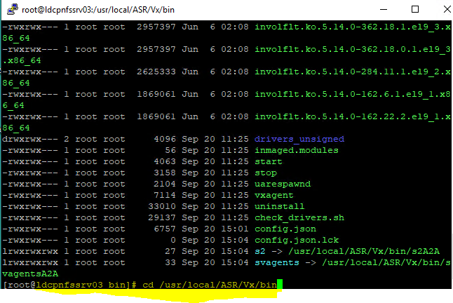

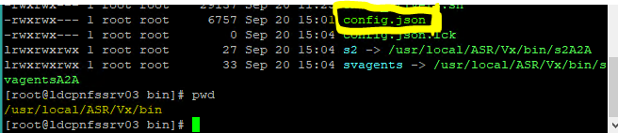

For Registration with ASR
[root@ldcpnfssrv03 bin]# pwd
/usr/local/ASR/Vx/bin
[root@ldcpnfssrv03 bin]# ./UnifiedAgentConfigurator.sh -S config.json -q -c CSPrime

[root@ldcpbreapp03 bin]# ./UnifiedAgentConfigurator.sh -S config.json -q -c CSPrime
Value of cstype is CSPrime
Platform value in drscout.conf: VmWare
Stopping Vx agent service...
Updating bios id in RCMInfo.conf
RCM agent registration has completed successfully.
Starting UA Respawn daemon...
Agent configuration is completed successfully.
Check the log file /var/log/ua_install.log for detailed diagnostic messages or configuration success/failures...
Configurator succeeding with exit code : 0
Configurator exiting with code: 0
[root@ldcpbreapp03 bin]#
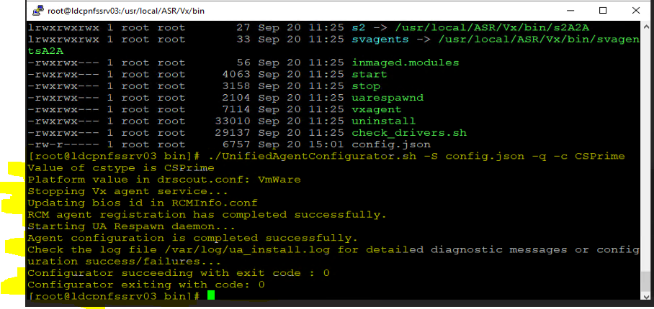

After that, need to works on the AZURE portal in ASR Vault

Open the Azure Portal and go to ASR.
About the Mobility service for disaster recovery of VMware VMs and physical servers with Azure Site Recovery - Azure Site Recovery | Microsoft Learn

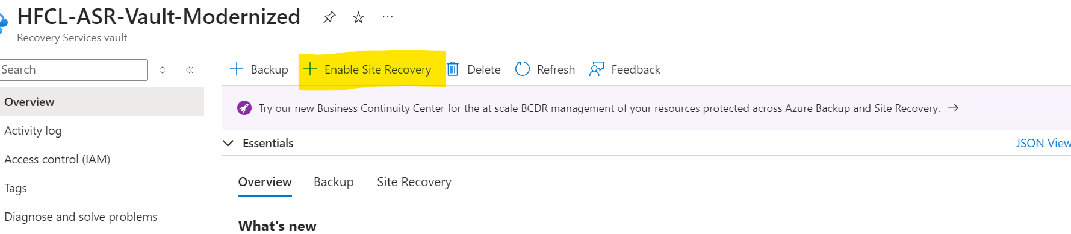

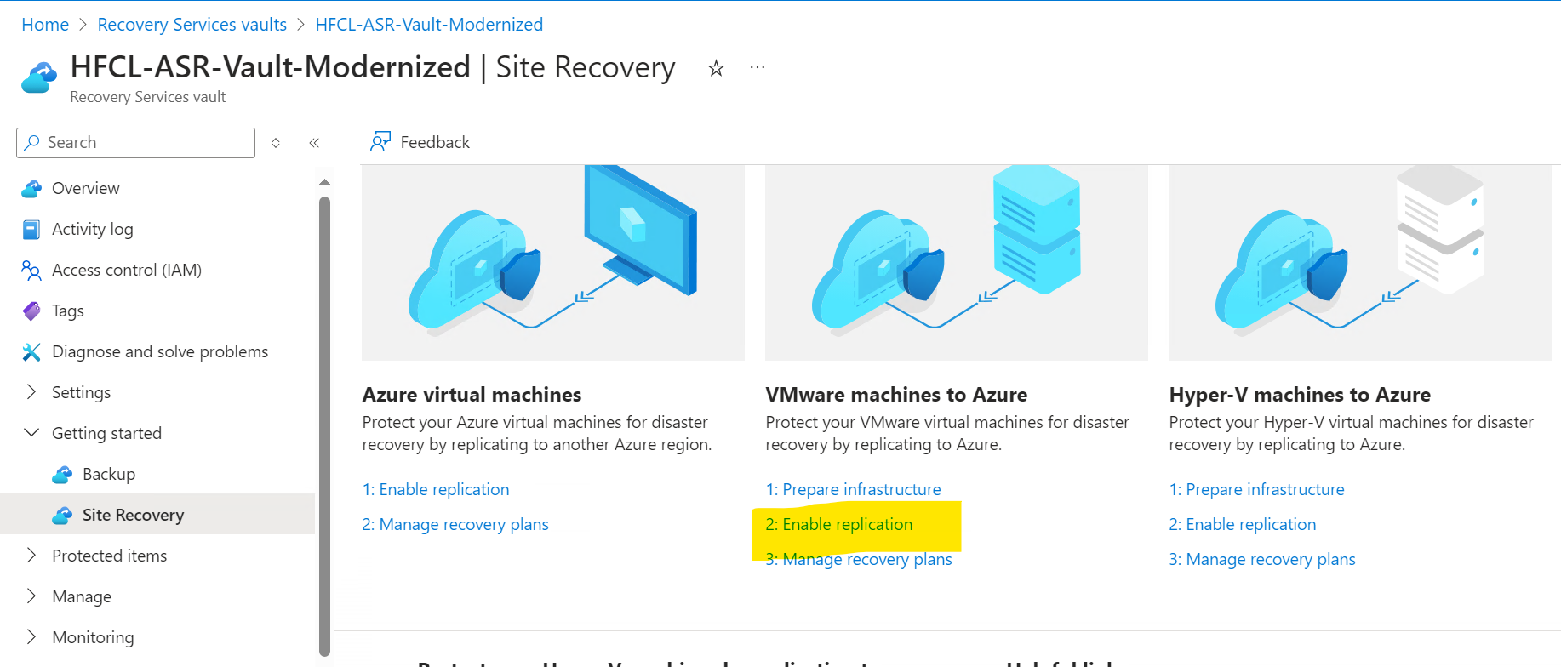
Search the VM which needs to be added in Replication.

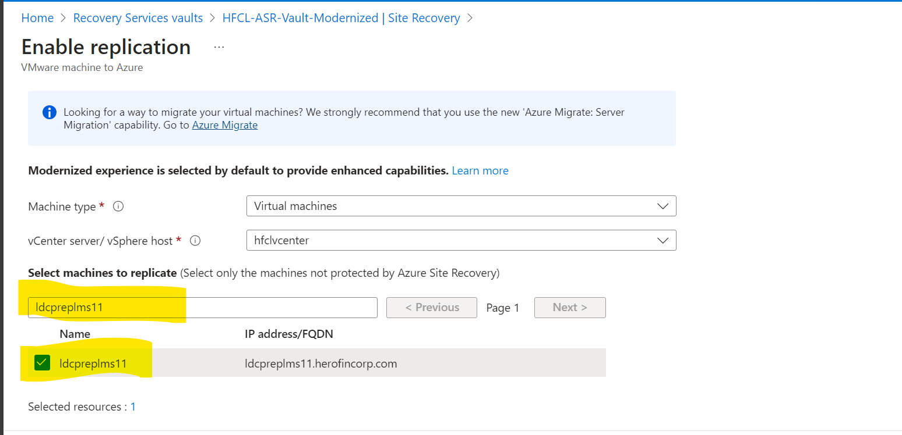

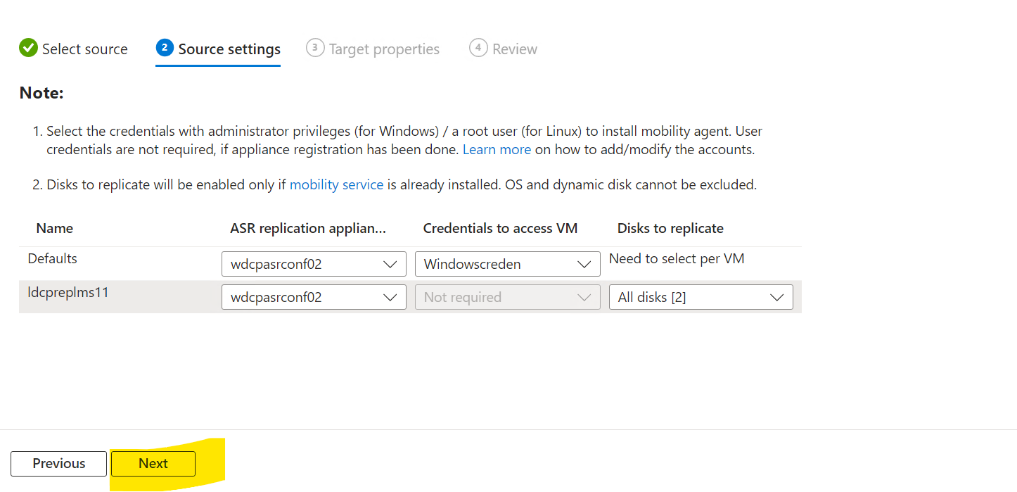
Add the following information.
- VNET
- Storage
- Replication Policy

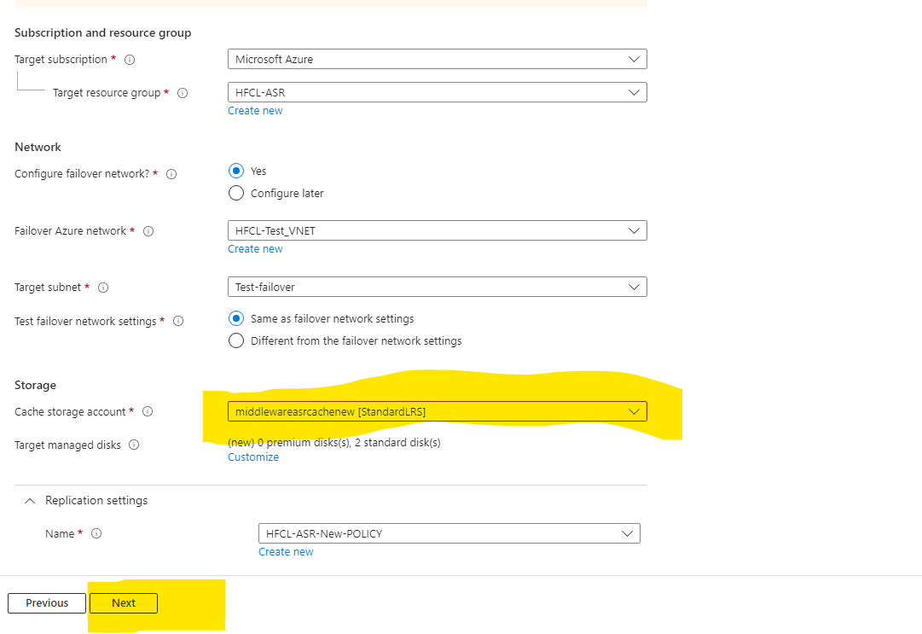
Enable Replication.
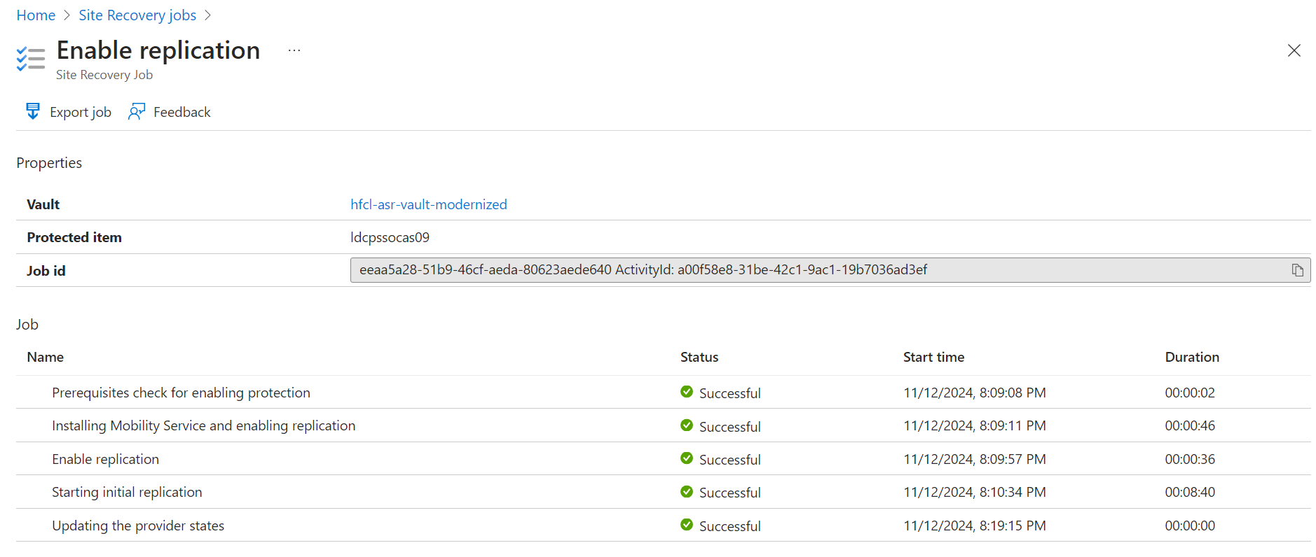

For agent removal and configuration in Linux follow the below article.
About the Mobility service for disaster recovery of VMware VMs and physical servers with Azure Site Recovery - Azure Site Recovery | Microsoft Learn

